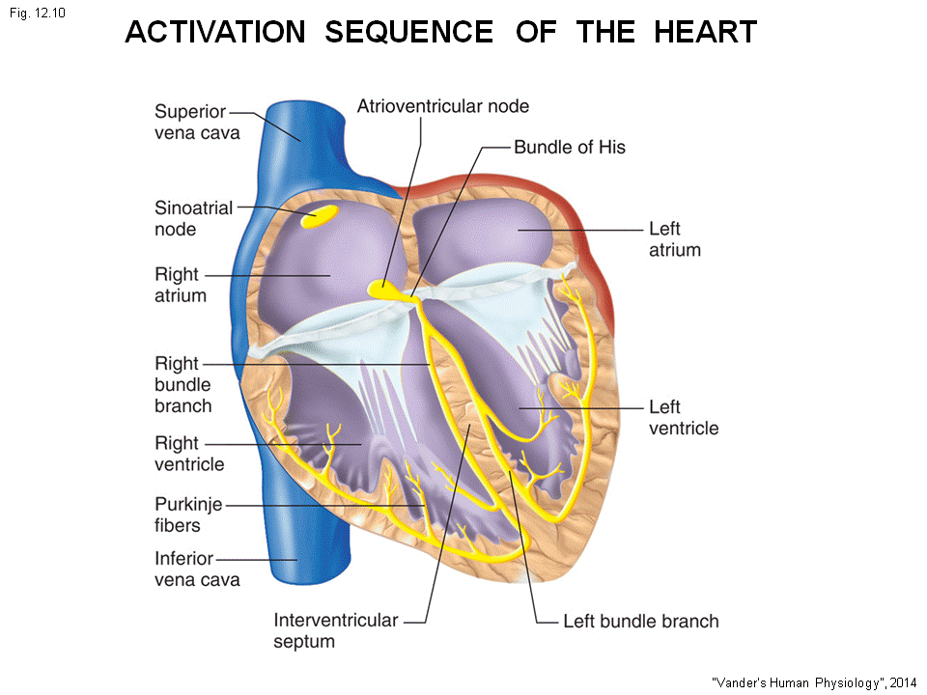
The activation start at sinoatrial node, this is the pace maker. This action spread through the atrium, down the bundle of his, down the bundle branch to the purkinje fibers. The fiber lines inner most surface area of the muscle. The action travel to endocardium and epicardium all at the same time.
- The purpose of the branching is to bring the action simultaneously to the endocardium at both ventricle. This allow both ventricle be activated at the same time.
- The action potential is what goes through the cells and cause action.
- The branching action allow the simultaneous contraction of all ventricle. Both contract at once and give a powerful contraction

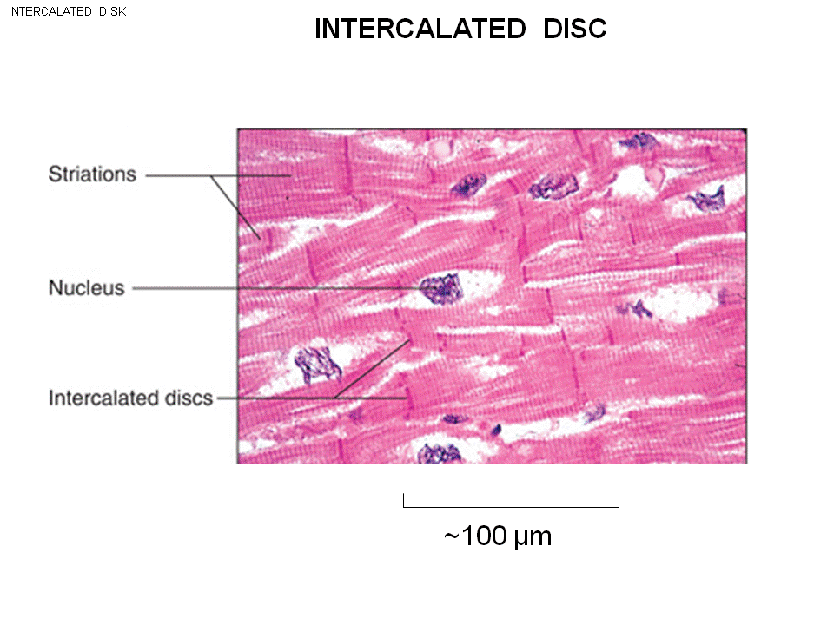
How do the action potential work through the heart?
- The action travel cell by cell.
- Under microscope, the cell is striated.
- The cell here is the working myocardium, cells are long.
- The action potential will be proprigate along the axis of the cell.
- Intercalated disk are the specialized structure joined the cells, this hold the 2 cells together. Allow the 2 cells to talk together

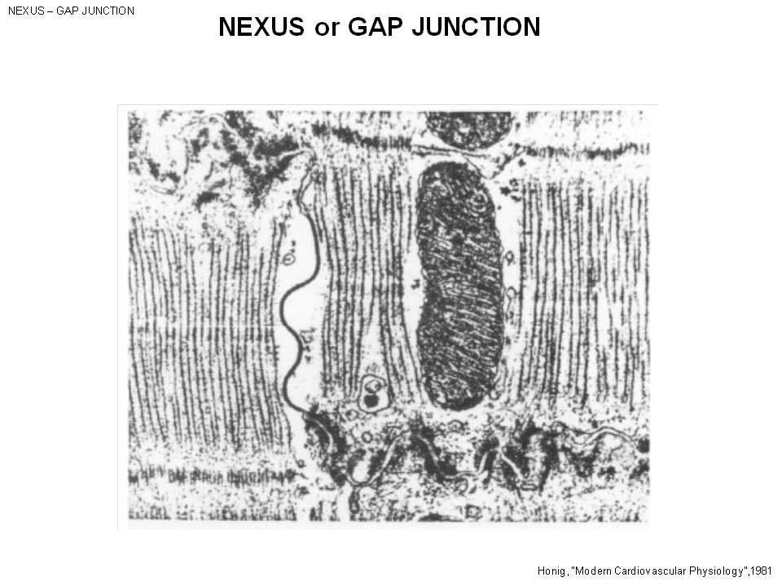
This is the single intercalated disc:
- This winding structure is the intercalated.
- The space between cells is called interstitial space.
- From left to right you see the interstitial space is gone , and the 2 membrane is close together. The gap junction is here.
- From the one side to another side is the gap junction (nexus)

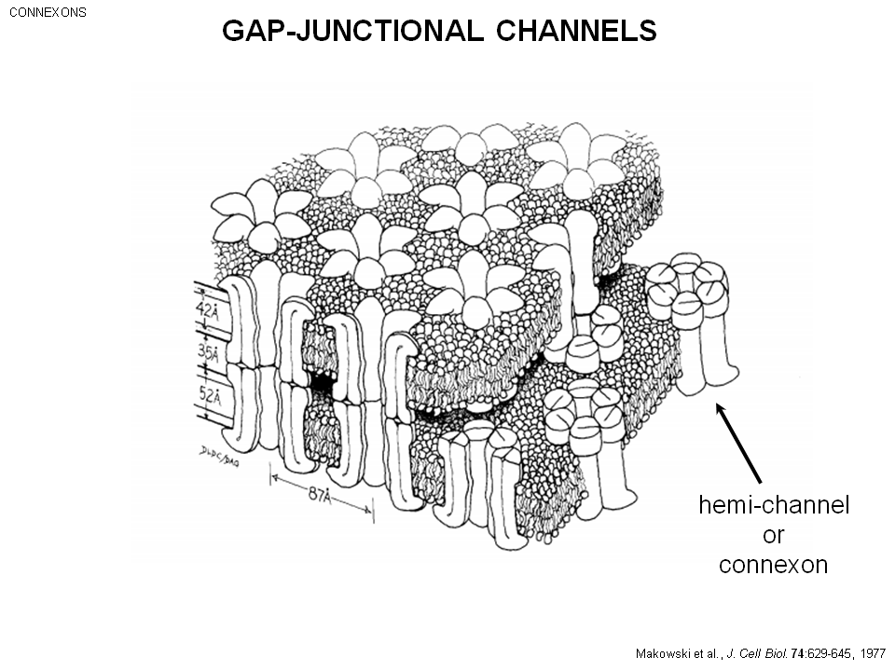

The gap junction channels.
- Half channel in one cell (hemi- channel or connexion)
- The lipid bilayer, the half channel duck with the half channel of the other channel. =. From the 6 subunit and a hole make a channel
- This is a huge channel (not sodium, K+ channels) the ions can easily move.
- The cells can talk to one another and this is how electric propagate.

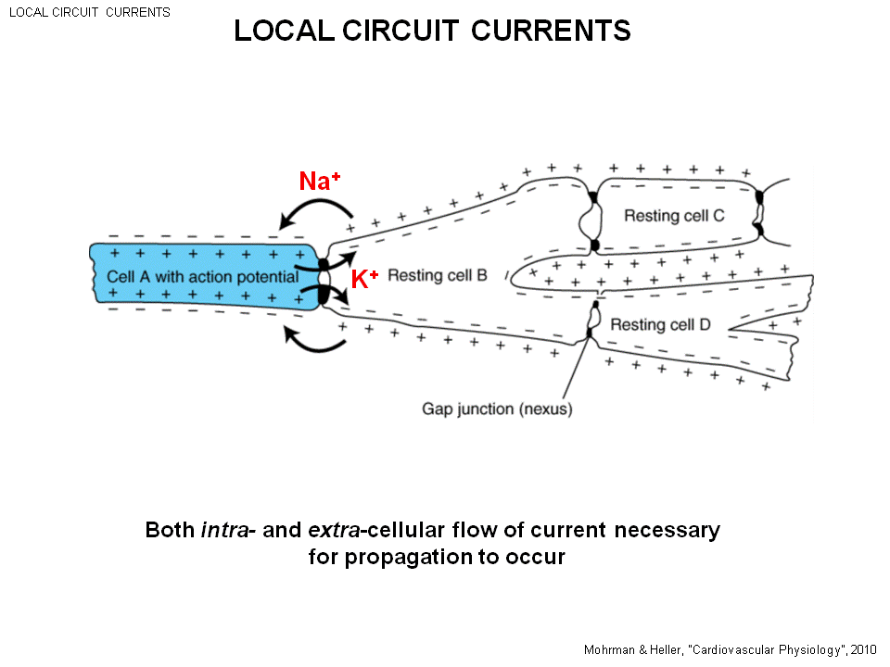
Look at a chunk of cardiac muscle in 3D. Assume the sinoatrial node is around, and this is a ventricular muscle. The action cell spread from cell to cell.
- The while color cell: haven’t be activated. (seating in a resting potential)
- The resting potential for working myocardial cell (the cell that work not specialized) has a resting potential of – 90mv. (rest in hyperpolarized like a brain cell. )
- The resting is the voltage inside is negative relative to the outside.
- Cell A is activated with upstroke of +40 mv. (-90 +40mv)
- If a potassium ion (K+) is in the activated cell and there is a gap junction: the negative charge (resting) cell will attract, and positive charge cell (activated) cell will repel. The positive ion will be repel by the activated cell and it will move through the gap junction channel.
- Na+ ion is going to move in a opposite direction than. This Na+ is in the outside of the cell, be repelled by the positive charge outside (resting cell), attract by the negative charge outside(activated cell)
- This give you a circuit. The flow of charge (current) MOVE IN A LOCAL LOOP. HAPPEN WHERE ACTIVATED CELL IS NEXT TO RESTING CELL.
- K+ is the predominate ion, have the highest concentration inside the cell.
- Na+ is the highest ion outside the cell.
- Note any positive ion inside the cell will move the same as k+
- any positive ion outside the cell will move the same as Na+
- Negative ion (CL-) inside the resting cell will move away to the activated cell.
- Negative ion outside the activated cell will move to the resting cell.
- The positive ion moves in to the resting cell, neutralize the negative ion. And the outside positive ion moves away from resting cell. Now there is no +ion outside, no -ion inside the membrane potential is 0 .
- The local current will depolarize (-90, -89, -88….) as the cell come out the polarized condition.
- When say the membrane is polarized means you have the two sets of charges.
- When depolarize = remove the polarization. The net direction 0.
- Eventually, as the potential goes from -90, -80…. At some point, this begin to active Na+, Cl+ current. Those channels will open: Na+ Cl + flow in to the cell, depolarized further. Give a upstroke of potential.
- The trick is the local circulation that cause the first bit of depolarization allow the other channels to open depolarize the cell upstroke of action potential activated the area (cell be active (started action potential) )
- This cell now goes from -90 to +40 mv. And this happen local circulation again Cell by cell activation
- If you have an axon (Action potential travel down in the exact same way, except the axon is a single cell ) but in cardiac cell you have the membrane connected by gap junction.
- The local circulation! Is the key.
- Need to have both Intracellular flow of current and outer cellular flow of current to take away pairs of charges.
- If do an experiment and put sucrose in the water no ions, the propagation will stop. Have to have both outside and inside circulation.
ECG:
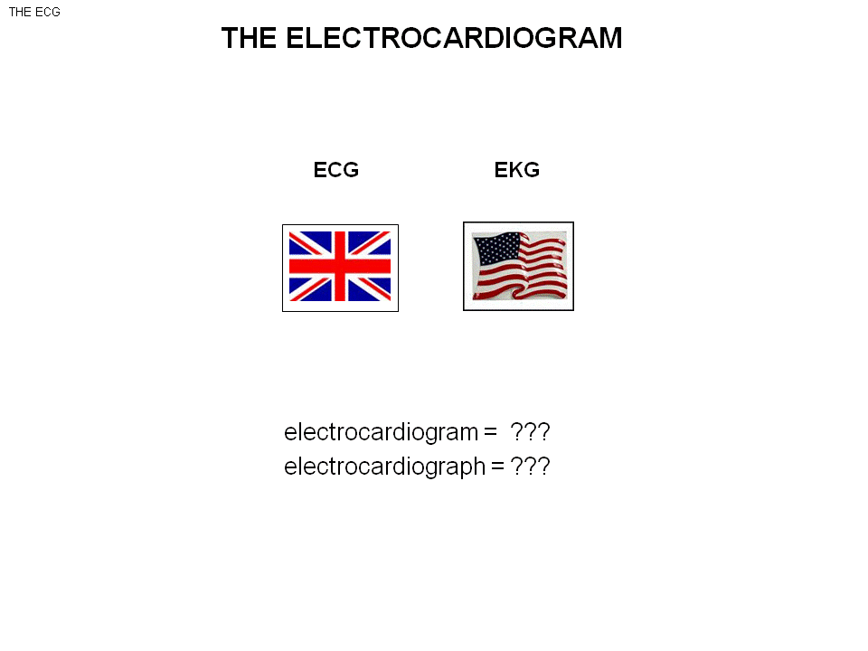
- You pick up the extracellular current of the heart.

Electo(electrical) cardo gram(recording) = record electro activity in the heart, extracellularly of the surface of body.
Electro cardio graph =instrument that make the recording. (the machine)

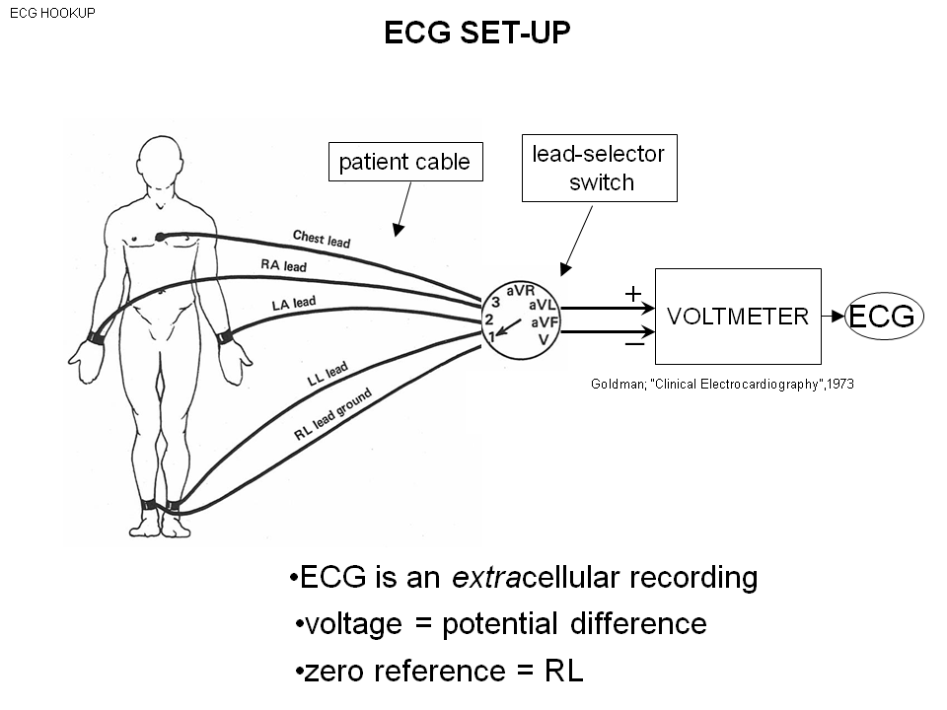
Volt (voltage) meter (measurement) , 2 leads come out( black --- negative, red ---positive) : you are measuring the voltage of plus terminal – the voltage of minus terminal. Ex: (6 -3)
ECG is a heart voltmeter, there is a bunch of wires and attach to the surface of the body. (left , right arm and leg and one to the chest)
There is a lead selector switch it hock the different combination to the voltmeter.
6 electrode attach to the chest
- Here left arm to the positive voltmeter
- Right arm to the negative voltmeter
- A full ECG Make 12 difference voltmeter
- EThis leads are just wires with electrode.
- Record the voltage difference between different surface of the body
- ECG is a extracellular recording (outside the cell)
- Voltage is the difference of potential (voltage is like a pressure, when say 120 V we mean difference of voltage is what we mean for 2 points.)
- The right leg is the 0 as ground.
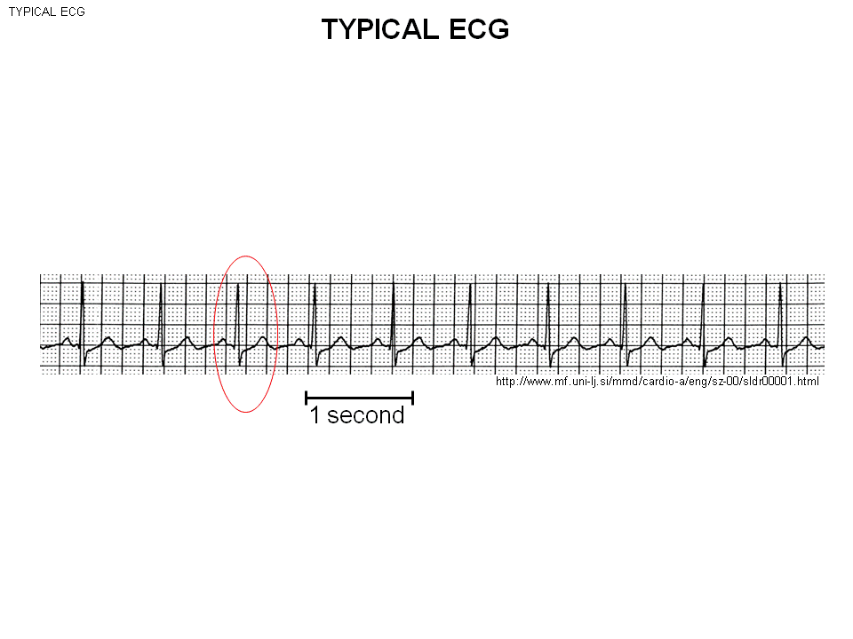

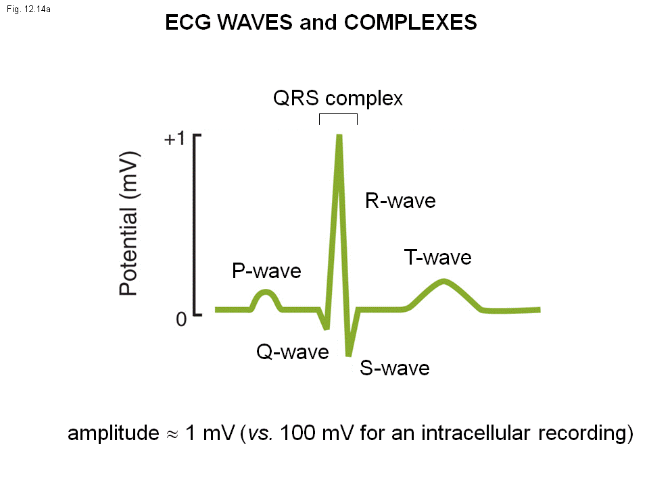

3 waves –P, QRS, T
- P
- The complex (QRS) – the 3 waves : Q -negative, R and S
- T
The typical QRS is on 1mv, so we measure on the scale of 1mv.
The action potential intracellularly (-90~~+40), so the scale should be 140mv( 40-(-90) = 130)
- when recording inside the cell the voltage picking is 100 times larger. This local current flow through entire body, so by the time they get to the body, the order of voltage is only 1 mv.

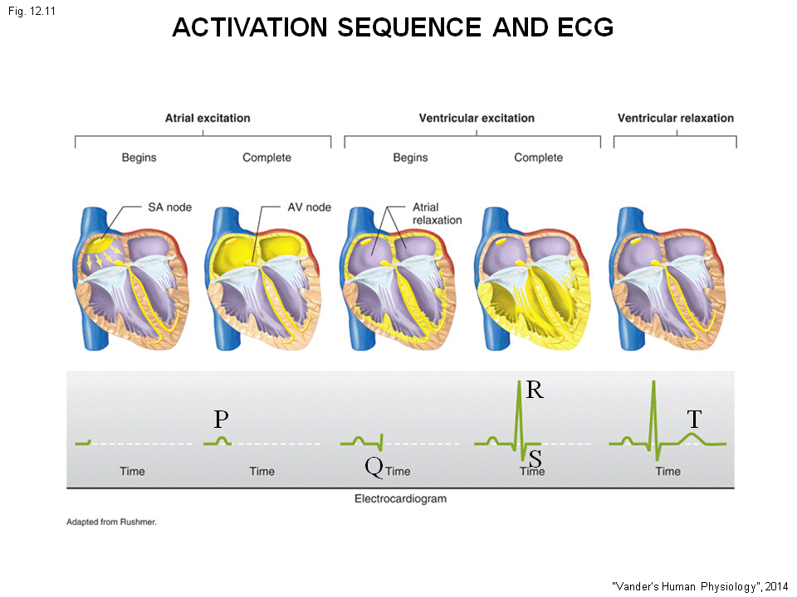
PQRST is connected with the activation sequence of the heart.
- SA- pace marker (a small structure , not much cell so don’t generate lots of current.) At the time get to the surface of body, it will lose in the noise. you see nothing in ECG
- So the SA node fire before the P wave, than the action potential goes out travel through right and left atrium. This is a large chunk of muscle. --- >p wave
- P wave is generated by the local circulation produce as the atrial cell is successfully activated. (SA fire before the P wave than travel to right and left atrium and this is )P wave = Atrium polarization
- The action potential travel through the AV node.
- AV node is about the same size as SA node, you pick up nothing
- Action potential then travel through the his bundle, branch on pirkinje fiber –nothing on ECG, (these structures are too small)
- Half way through the P wave action potential enter the AV node, than to his bundle, branches , pirkinje fibers ( all these have no signal )
- Only the activation potential exist the perkinje fiber ( to the huge amount of cell -right and left ventricle, intraventricular septum) ACTIVATED see the big wave
- The huge amount of cell give the QRS complex – the activation of ventricular muscle
--Activation : the upstroke of action potential
-- Repolarization followed: certain cell activated earlier will be repolarized (they seat beside the cell that are still activated one cell -repolarized, other cell – not repolarized ) ---local circuit flow.
2 sets of local circuit current: 1 set involve in depolarization in heart, another is the repolarization in the cells.
- T wave is the repolarization of ventricular muscle
P wave – depolarization of the atria
QRS – the depolarization of the ventricles
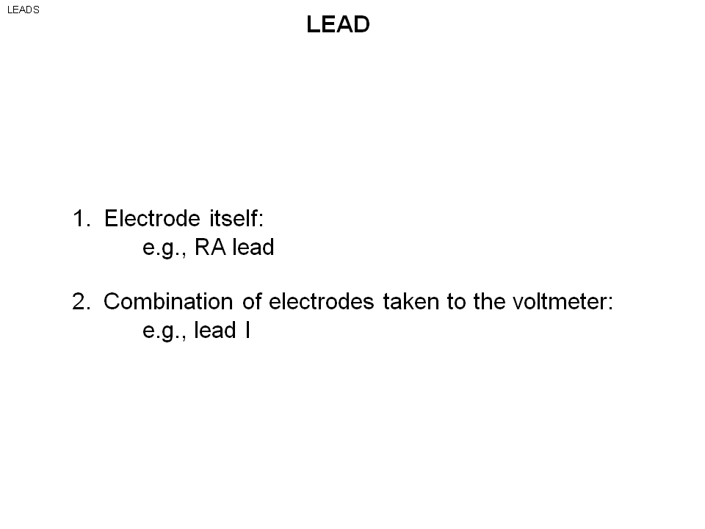
T wave – repolarization of the ventricle

Lead is used to in 2 ways:
Right arm lead: the wire of ECG
Lead ----which of these electrode is hooked up to the recordings.

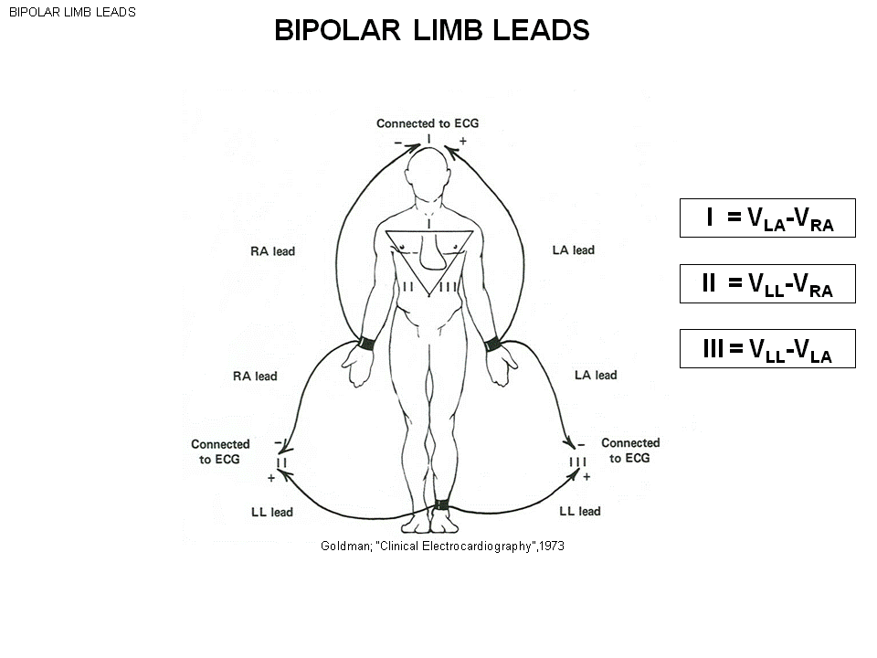
There is 12 leads on the ECG.

Bipolar limb leads –the limb leads mean we make recording from the limb (arms and leg)
- Bipolar: 2 of them, we make the voltage difference between two of them.
To record lead one :
Turn switch 1 => take the right arm lead to the (-) of the voltmeter, the left arm lead to the (+) of the voltmeter. The output of the voltmeter : ( the Voltage of left arm – the voltage on right arm ) = lead 1
- Lead 1 = voltage difference between left and right arm
Note you don’t have a right leg connection to the ECG, because the right arm is always at minus terminal
Lead 2 => The right arm lead to the - terminal, and the left leg lead to the + terminal.
(Left leg – Right arm) = lead 2
Lead 3 (left leg – left arm)

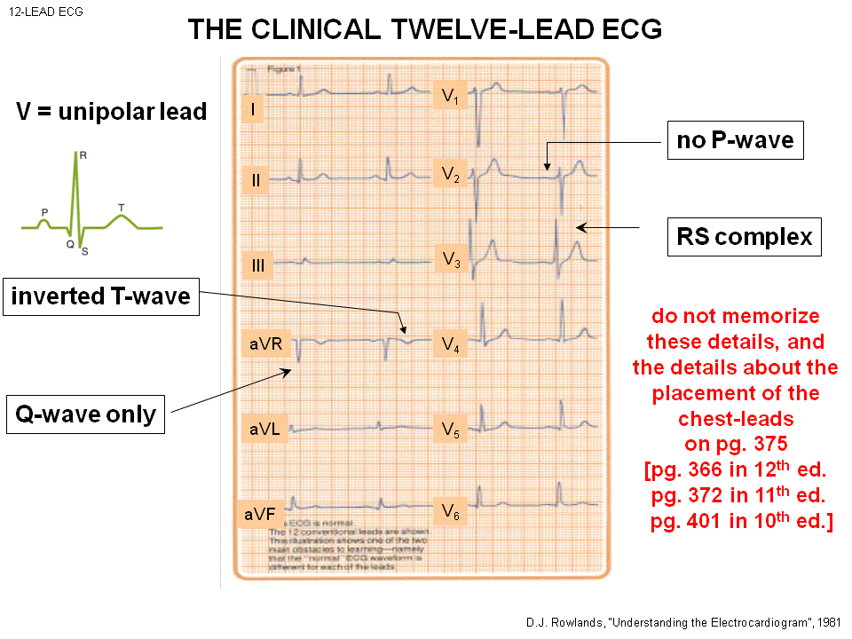
Lead 1, lead2 , lead 3 are the 3 bipolar limb leads .

You can see the each recording are different.
- The activation is moving in a particular direction, In this 12 leads. you are taking a projection in the 3D movement on to the line.
Ex: In Lead 1, the lead axis is in particular direction. The action potential is moving in a complicated 3D way with changing in time. We take the projection of this 3D movement vector on to this axis. As using different axis, you take different projections of these 3D spread.
- Note in less 9 V there is a capital V, this means it’s a unipolar leads not a bipolar leads .
- Add up the voltage of the 3 places of the body, the voltage always = 0.
- Take 3 leads, add the voltage in the machine =0. Take this to minus terminal of the voltmeter. So! The minus terminal is 0 all the time.
- Than you take the leads coming out from the plus terminal of the voltmeter, this is the unipolar leads.
- Put anywhere of this of the body : the voltage is this - 0 = this (so you pick the voltage of the surface of the body )
aVR ( r= RIGHT ARM ) aVl ( left arm ) aVF( left foot ), these are the unipolar of the limb leads.( capital V= unipolar )
V1 ~~V6 are the chest leads.
- There isn’t any leads show a PQRST wave. –why ? because you look at the electrode recording from different direction. This is why we need to get 12 leads to get a good 3D activity;
- No p wave
- Inverted T wave : normal in aVr
- Q wave is the first go to the negative, than R is the positive followed by, S is the negative followed .
- Missing RS ……..
- RS COMPLEX: miss Q

- Need to get 12 leads! To see the whole 3D.

- You only need to now lead 1 lead 2 lead3 the placing location

ECG is produce by local circulating current. The local circulating current is by the cell has action potential.
EEG is the recording of local circle current. of the brain cell
EMG also external local circle current. They are generated by the fact of action potential occur.
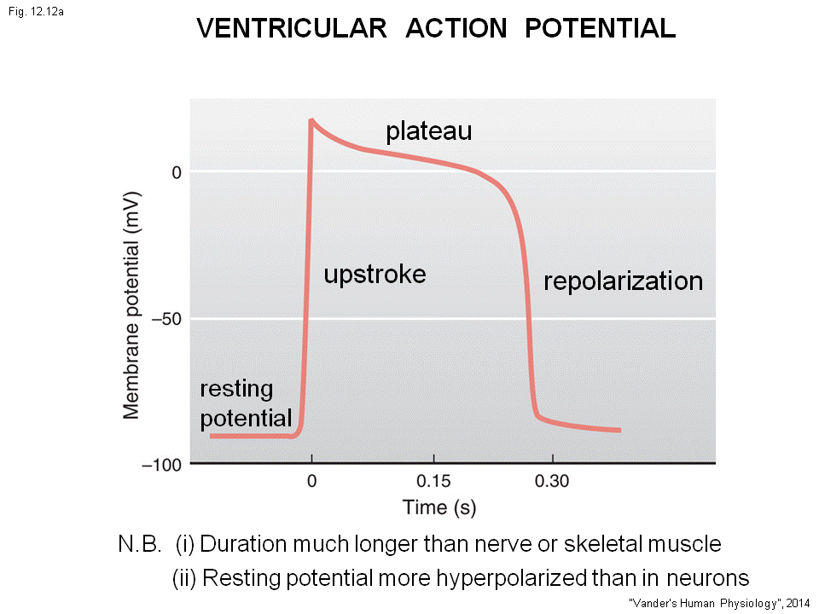
This is the recording of the action potential by one electrode in the cell, and one electrode out the cell and pick the voltage difference across the membrane.
In cardiac cells,
- - 90 resting potential in the ventricle (ventricle is very important in the heart)
- The cell is resting, and the cell beside is activated generate local circuit current, this cell will have depolarized to specific voltage cause Na+ channel to open. (Na+ channel open and generate the upstroke )
Look at the scale we can tell the action potential is 300mmsec (In neuron the average duration is 5~19 mmsec (much shorter ) )

- In cardiac muscle there is a Plateau phase of the action potential (flat)
- Repolarization
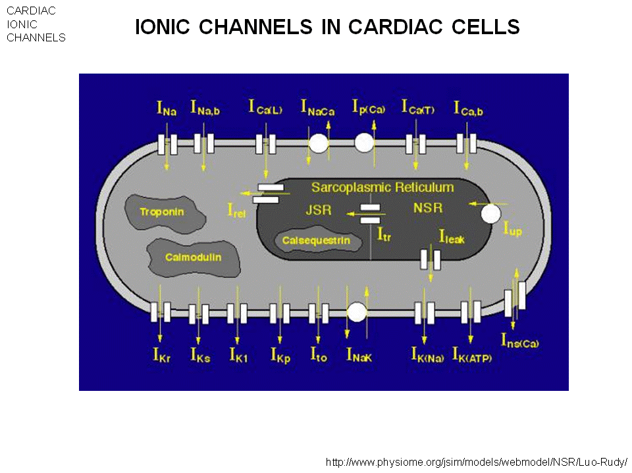

There is a lot of channels – each channel is a protein with specific structure.
Why call sodium channel? --allow only Na + through. (same for K+ channel )
- There is also :
- 2 kinds of Ca+ channel :Ica(L) Ica(T)
- At least 6 K+ channels in the heart.

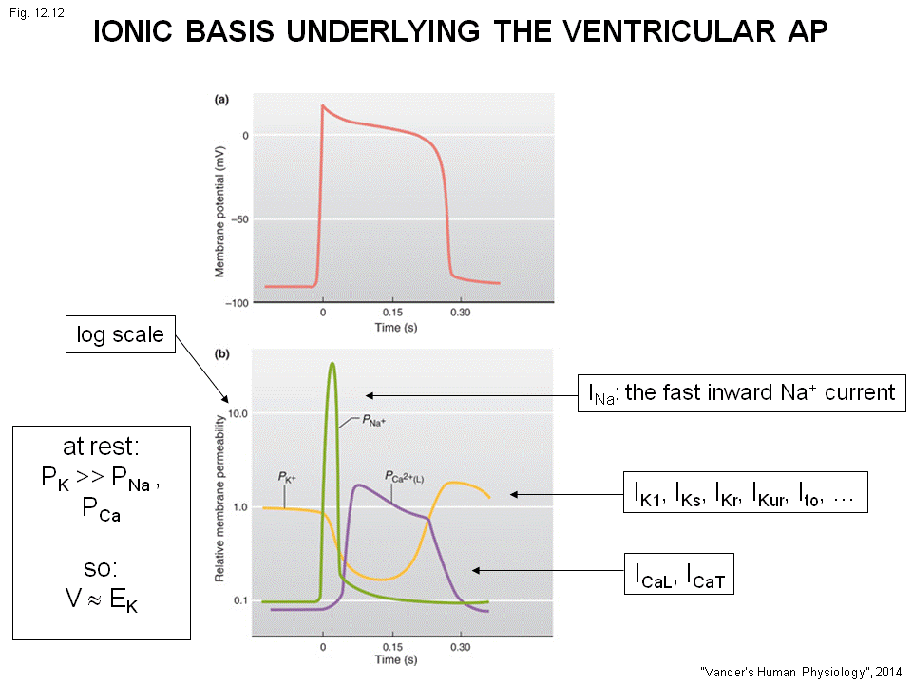
The y axis is the permeability of membrane in a log scale, so at 10 is 100 times as big as at 0.1.
Ex: Na+ channel at 10 , means Na+ channels open up allow Na+ move from outside to inside. Same for Ca+ and K+ channel.
- The cell is resting , and the local circulating current comes.==> reach specific voltage , Na+ voltage channel is sensitive, at rest the permeability of Na+ is very small, but now reach threshold and rapid open of Na+ channel. + ions comes in depolarize.
- The upstroke is generated by the Na+ influx by Na+ channel that open.
- and the channel close quickly . The function of Na+ comes in is to excite the cell to start up the action potential. this is call activation (channel open) and inactivation (channel close)
- This current is called Ina+ = fast inward sodium current. (Na+ current is inward and turns on quick )
K+ channel dominate at rest (The equilibrium of K+ is around -100, this is why we have a low resting potential )these cells seats at -90.( Try to think K+ membrane ) As the voltage increase the channel will close ( Sense voltage goes up and close, permeability to K+ will fall)
The Ca+ channels reach much slowlythe permeability increase and stay , Slow activation and slow inactivation
- The red upstroke of voltage increase is sense by the Ca+ channel cause more to open but quite late.
- Ica +sense but late, the permeability increase and stay a bit. Then the channel will close (slower activation of the Ca+ channel and slower inactivation)
- There is lot more Ca+ outside the cell than inside the cell, so the Ca+ influx. Cell contract.
K+ channel is also slow , when they sense the repolarize more open up and the potassium will leave the cell. (+Ion leave, inside more negative ----repolarization)
Local circle current produce the foot of action potential, activate Na+ channel , Na+ influx, later Ca+ channel open K+ channel close again and repolarize

